

Минобрнауки России

Федеральное государственное бюджетное образовательное учреждение

высшего образования

**«САРАТОВСКИЙ национальный исследовательский ГОСУДАРСТВЕННЫЙ УНИВЕРСИТЕТ ИМЕНИ Н.Г. ЧЕРНЫШЕВСКОГО»**

Кафедра информатики и программирования

ОТЧЁТ

**Информатика и программирование**

студента 1 курса 141 группы   
направления 02.03.03 «Математическое обеспечение и администрирование  
информационных систем»  
факультета компьютерных наук и информационных технологий

Смыслова Антона Сергеевича

Саратов 2022

**1-I-8**

|  |
| --- |
| **C:\Users\1\Documents\ShareX\Screenshots\2022-12\firefox_XmQvKih7L3.png** |
| **C:\Users\1\Documents\ShareX\Screenshots\2022-12\firefox_ovVJcWpQrM.png** |
| #include <iostream>  #include <math.h>  using namespace std;  int main() {  double x, y;  cin >> x >> y;  cout << (1 + exp(y-1)) / (1+(pow((x),2))) \* (abs(y-(tan(x))));  return 0;  } |

**Таблица значений**

|  |  |
| --- | --- |
| **Input** | **Output** |
| **5 1** | **0.336963** |
| **12 10** | **594.441** |

**1-II-13**

|  |
| --- |
| **C:\Users\1\Documents\ShareX\Screenshots\2022-12\firefox_XmQvKih7L3.png** |
|  |
| #define \_USE\_MATH\_DEFINES  #include <iostream>  #include <math.h>  using namespace std;  int main() {  int l;  cin >> l;  cout << l / (2 \* M\_PI);  return 0;  } |

**Таблица значений**

|  |  |
| --- | --- |
| **Input** | **Output** |
| **3** | **0.477465** |
| **13** | **2.38732** |

**1-III-2**

|  |
| --- |
| **C:\Users\1\Documents\ShareX\Screenshots\2022-12\firefox_XmQvKih7L3.png** |
|  |
| #include <iostream>  #include <cmath>  using namespace std;  int main() {  setlocale(LC\_ALL, "Russian");  int x;  cin >> x;  if (x % 2)  cout << "Число Нечётное";  else  cout << "Число чётное";  return 0;  } |

**Таблица значений**

|  |  |
| --- | --- |
| **Input** | **Output** |
| **5** | **Число Нечётное** |
| **2** | **Число чётное** |

**3-I-6**

|  |
| --- |
|  |
|  |
| #include <iostream>  using namespace std;  int main() {  int x, y, r;  cin >> x >> y;  if (x \* x + y \* y > 25 \* 25 || x \* x + y \* y < 15 \* 15) {  cout << "Vhodit";  }  else if (x \* x + y \* y > 15 \* 15 && x \* x + y \* y < 25 \* 25) {  cout << "Ne vhodit";  }  else {  cout << "na granitse";  }  } |

**Таблица значений**

|  |  |
| --- | --- |
| **Input** | **Output** |
| **0 15** | **na granitse** |
| **15 15** | **Ne vhodit** |
| **25 25** | **Vhodit** |

**3-II-15**

|  |
| --- |
|  |
|  |
| #define \_USE\_MATH\_DEFINES  #include <iostream>  #include <algorithm>  #include <cmath>  using namespace std;  int main() {  setlocale(LC\_CTYPE, "Russian");  cout << "Введите номер фигуры: 1 - Круг; 2 - Прямоугольник; 3 - Треугольник" << endl;  double a, b, c, r, p;  int x;  cin >> x;  switch (x) {  case 1:  cout << "Введите радиус" << endl;  cin >> r;  cout << M\_PI \* pow(r, 2);  break;  case 2:  cout << "Введите стороны" << endl;  cin >> a >> b;  cout << a \* b;  break;  case 3:  cout << "Введите стороны" << endl;  cin >> a >> b >> c;  p = (a + b + c) / 2.;  cout << sqrt(p \* (p - a) \* (p - b) \* (p - c));  break;  default: x;  }  } |

**Таблица значений**

|  |  |
| --- | --- |
| **Input** | **Output** |
| **(1) 2** | **12.5664** |
| **(2) 4 5** | **20** |
| **(3) 5 6 7** | **14.6969** |

**3-III-14**

|  |
| --- |
|  |
|  |
| **FOR**  #include <iostream>  using namespace std;  int main() {  int a, b, i;  cin >> a >> b;  for (i = a; i <= b; i++) {  if (i % 3 == 0) {  cout << "Opa= " << i << endl;  }  }  }  **WHILE**  #include <iostream>  using namespace std;  int main() {  int a, b, i;  cin >> a >> b;  i = a;  while (i <= b) {  if (i % 3 == 0) {  cout << "Opa =" << i << endl;  }  i++;  }  }  **DO WHILE**  #include <iostream>  using namespace std;  int main() {  int a, b, i;  cin >> a >> b;  i = a;  do {  if (i % 3 == 0) {  cout << "Kill me = " << i << endl;  }  i++;  }  while (i <= b);  } |

**Таблица значений**

|  |  |
| --- | --- |
| **Input** | **Output** |
| **2 10** | **Opa= 3**  **Opa= 6**  **Opa= 9** |

**3-IV-15**

|  |
| --- |
|  |
|  |
| #include <iostream>  using namespace std;  int main()  {  for (int i = 1; i <= 5; ++i, cout << endl) {  for (int j = 0; j < i; j += 1) {  cout << i << "\t";  }  cout << endl;  for (int j = 0; j < i; j += 1) {  cout << 0 << "\t";  }  }  return 0;  } |

**Таблица значений**

|  |  |
| --- | --- |
| **Input** | **Output** |
|  | **1**  **0**  **2 2**  **0 0**  **3 3 3**  **0 0 0**  **4 4 4 4**  **0 0 0 0**  **5 5 5 5 5**  **0 0 0 0 0** |

**2-10**

|  |
| --- |
|  |
|  |
| #include <iostream>  using namespace std;  int f(int &x) {  if (x % 2 == 0) {  x = x / 2;  }  else {  x = 0;    }  return 0;  }  int main() {  int i, d;  cin >> i;  f(i);  cout << i;  } |

**Таблица значений**

|  |  |
| --- | --- |
| **Input** | **Output** |
| **2** | **1** |
| **5** | **0** |

**3-V-5**

|  |
| --- |
|  |
|  |
| #include <iostream>  #include <cmath>  using namespace std;  int opa(float x) {  if (x < 1) {  cout << "Nein";  }  else {  return log(x - 1);  }  }  int main() {  float a, b, h, x;  cout << "a= ";  cin >> a;  cout << "b= ";  cin >> b;  cout << "h= ";  cin >> h;  cout << "x\tf(x)\n";  for (x = a; x <= b; x += h) {  cout << x << "\t";  cout << opa(x);  cout << endl;  }  return 0;  } |

**Таблица значений**

|  |  |
| --- | --- |
| **Input** | **Output** |
| **A= 3**  **B= 10**  **H= 2** | **x f(x)**  **3 0**  **5 1**  **7 1**  **9 2** |

**3-VI-18**

|  |
| --- |
|  |
|  |
| #include <iostream>  #include <cmath>  using namespace std;  double died(double x) {  if (x < 3) {  return pow(x, 2) - 0.3;  }  else if (x >= 3 && x <= 5) {  return 0;  }  else if (x > 5) {  return pow(x, 2) + 1;  }  }  int main() {  float a, b, h, x;  cout << "a= ";  cin >> a;  cout << "b= ";  cin >> b;  cout << "h= ";  cin >> h;  cout << "x\tf(x)\n";  for (x = a; x <= b; x += h) {  cout << x << "\t";  cout << died(x);  cout << endl;  }  } |

**Таблица значений**

|  |  |
| --- | --- |
| **Input** | **Output** |
| **A= 2**  **B= 10**  **H= 2** | **x f(x)**  **2 3.7**  **4 0**  **6 37**  **8 65**  **10 101** |

**4-15**

|  |
| --- |
| **C:\Users\1\Documents\ShareX\Screenshots\2022-12\firefox_oF3BYFTH1F.png** |
|  |
| #include <iostream>  #include <cmath>  using namespace std;  int main() {    float b1 = 1., b2 = 2., b;  b = 0;  int n;  cin >> n;  for (int i = 3; i <= n; i++) {  b = (b1 / 4.) + (5. / (b2 \* b2));  b1 = b2;  b2 = b;  }  cout << b;  return 0;  } |

**Таблица значений**

|  |  |
| --- | --- |
| **Input** | **Output** |
| **5** | **1.04972** |

**5-I-9**

|  |
| --- |
|  |
|  |
| #include <iostream>  #include <cmath>  using namespace std;  int main() {  int n, a, b,c;  a = 1;  b = 0;  cin >> n;  for (int i = 1; i <= n; i++) {  a \*= i;  b += a;  }  cout << b;  } |

**Таблица значений**

|  |  |
| --- | --- |
| **Input** | **Output** |
| **5** | **153** |
| **12** | **522956313** |

**5-II-6**

|  |
| --- |
|  |
|  |
| #include <iostream>  #include <cmath>  using namespace std;  int main() {  int n, a, b,c;  a = 1;  b = 0;  cin >> n;  for (int i = 1; i <= n; i++) {    a \*= i;  b += a;  }  cout << b;  } |

**Таблица значений**

|  |  |
| --- | --- |
| **Input** | **Output** |
| **2** | **1.25** |
| **12** | **1.3179** |
| **100** | **inf** |

**5-III-18**

|  |
| --- |
|  |
|  |
| #include <iostream>  #include <cmath>  using namespace std;  int main() {  double n, a, b, c, e;  c = 0;  b = -1./4;  cin >> e;  while (abs(b) > e) {  c += b;  b \*= -1. / 4;  }  cout << c;  } |

**Таблица значений**

|  |  |
| --- | --- |
| **Input** | **Output** |
| **0.125** | **-0.25** |
| **0** | **-0.2** |

**8-I-5-1**

|  |
| --- |
| **C:\Users\1\Documents\ShareX\Screenshots\2022-12\firefox_DimrpyI8yM.png** |
|  |
| #include <iostream>  #include <iomanip>  using namespace std;  int sueta(int a, int b) {  for (int i = a; i > 0; i--) {  if (a % i == 0 && b % i == 0) {  return i;  }  }  }  int main() {  int a, b, i,c;  double o;  cin >> a >> b;  i = sueta(a, b);    cout << a/i << "/" << b/i;  }  } |

**Таблица значений**

|  |  |
| --- | --- |
| **Input** | **Output** |
| **100 20** | **5/1** |
| **1000 5** | **200/1** |

**6-I-15-динам**

|  |
| --- |
|  |
|  |
| **Одномерный**  #include <iostream>  using namespace std;  int main() {  int n;  cin >> n;  int\* a=new int[n];  for (int i = 0; i < n; i++) {  int k;  cin >> k;  a[i] = k;  }  for (int i = 0; i < n; i++) {  if (a[i] % 7 != 0) {  cout << "nomer= " << i+1 << "\t" << i << endl;  }  }  }  Двумерный  #include <iostream>  using namespace std;  int main() {  int n, m;  cin >> n >> m;  int\*\* a = new int\* [n];  for (int i = 0; i < n; i++) {  a[i] = new int[m];  }  for (int i = 0; i < n; i++) {  for (int j = 0; j < m; j++) {  cin >> a[i][j];  }  }  int c = 1;  for (int i = 0; i < n; i++) {    for (int j = 0; j < m; j++) {  if (a[i][j] % 7 != 0) {  cout << c << "\t";  }  c++;  }  cout << endl;  }  } |

**Таблица значений**

|  |  |
| --- | --- |
| **Input** | **Output** |
| **(7)**  **1**  **2**  **7**  **3**  **21**  **43**  **11** | **nomer= 1 0**  **nomer= 2 1**  **nomer= 4 3**  **nomer= 6 5**  **nomer= 7 6** |
| **(3 3)**  **1 41 14**  **31 21 2**  **11 12 14** | **1 2**  **4 6**  **7 8** |

**6-I-15-стат**

|  |
| --- |
| C:\Users\1\Documents\ShareX\Screenshots\2022-12\firefox_PmFD1L5ojD.png |
| C:\Users\1\Documents\ShareX\Screenshots\2022-12\firefox_NRzDCgTJlI.png |
| Одномерный  #include <iostream>  using namespace std;  int main() {  int n;  int a[101];  for (int i = 0; i < n; i++) {  cin >> a[i];  }  for (int i = 0; i < n; i++) {  if (a[i] % 7 != 0) {  cout << "nomer= " << i + 1 << "\t" << i << endl;  }  }  }  Двумерный  #include <iostream>  using namespace std;  int main() {  int n, m;  cin >> n >> m;  int a[101][102];  for (int i = 0; i < n; i++) {  for (int j = 0; j < m; j++) {  cin >> a[i][j];  }  }  int c = 1;  for (int i = 0; i < n; i++) {    for (int j = 0; j < m; j++) {  if (a[i][j] % 7 != 0) {  cout << c << "\t";  }  c++;  }  cout << endl;  }  } |

**Таблица значений**

|  |  |
| --- | --- |
| **Input** | **Output** |
| **(7)**  **1**  **2**  **7**  **3**  **21**  **43**  **11** | **nomer= 1 0**  **nomer= 2 1**  **nomer= 4 3**  **nomer= 6 5**  **nomer= 7 6** |
| **(3 3)**  **1 41 14**  **31 21 2**  **11 12 14** | **1 2**  **4 6**  **7 8** |

**6-II-5**

|  |
| --- |
|  |
|  |
| #include <iostream>  using namespace std;  int main() {  int n, c, x;  cin >> n;  int maxi = -1000000;  int mini = 100000;  int a[101];  for (int i = 0; i < n; i++) {;  cin >> a[i];  if (a[i] > maxi) {  maxi = a[i];  c = i;  }  }  x = a[0];  a[0] = maxi;  a[c] = x;  for (int i = 0; i < n; i++) {  cout << a[i] << " ";  }  } |

**Таблица значений**

|  |  |
| --- | --- |
| **Input** | **Output** |
| **(5) 1 2 3 4 5** | **5 2 3 4 1** |

**6-III-4**

|  |
| --- |
| **C:\Users\1\Documents\ShareX\Screenshots\2022-12\firefox_h1tJnXe04f.png** |
|  |
| #include <iostream>  using namespace std;  int main() {  int n, m;  int s = 0, counter = 0;  cin >> n >> m;  int\*\* a = new int\* [n];  for (int i = 0; i < n; i++) {  a[i] = new int[m];  }  for (int i = 0; i < n; i++) {  for (int j = 0; j < m; j++) {  cin >> a[i][j];  }  }  for (int i = 0; i < n - 1; i++) {  for (int j = 0; j < n - i - 1; j++) {  if (a[i][j] != 0) {  s += a[i][j];  counter++;  }  }  }  cout << s / (counter \* 1.);  } |

**Таблица значений**

|  |  |
| --- | --- |
| **Input** | **Output** |
| **(3 3)**  **1 2 3**  **4 5 6**  **7 8 9** | **2.33333** |

**6-IV-15**

|  |
| --- |
|  |
|  |
| #**include** <iostream>  **using** **namespace** std;  **int** **main**(){  **int** \*\*matrix;  **int** n, m;  setlocale(LC\_ALL, "Russian");  cout << "Введите n m\n";  cin >> n >> m;  cout << "Введите k1, k2\n";  **int** k1, k2;  cin >> k1 >> k2;  **int** \*ans = **new** **int**[m];  **for** (**int** i = 0; i < m; i++)  ans[i] = 1;  matrix = **new** **int** \*[n];  **for** (**int** i = 0; i < n; i++)  matrix[i] = **new** **int**[m];  cout << "Введите массив по строчкам\n";  **for** (**int** i = 0; i < n; i++)  **for** (**int** j = 0; j < m; j++)  cin >> matrix[i][j];  **for** (**int** j = 0; j < m; j++){  **for** (**int** i = k1; i <= k2; i++){  ans[j]\*=matrix[i][j];  }  }  **for** (**int** i = 0; i < m; i++){  cout << ans[i] << " ";  }  } |

**Таблица значений**

|  |  |
| --- | --- |
| **Input** | **Output** |
| **(3 3) [1 2]**  **1 2 3**  **4 5 6**  **7 8 9** | **28 40 54** |

**6-V-5-Delete**

|  |
| --- |
|  |
|  |
| #include <iostream>  using namespace std;  int main() {  int n, k1, k2;  cin >> n;  cin >> k1 >> k2;  int\* a = new int[n];  for (int i = 0; i < n; i++) {  cin >> a[i];  }  for (int i = 0; i < n; i++) {  if (i >= k1 && i <= k2) {  for (int j = i; j < n; j++) {  a[j] = a[j + 1];  }  n--;  k2--;  i--;  }  }  for (int i = 0; i < n; i++) {  cout << a[i] << " ";  }  } |

**Таблица значений**

|  |  |
| --- | --- |
| **Input** | **Output** |
| **(5) [1 3] 1 2 3 4 5** | **1 5** |
| **(10) [3 5] 1 2 3 4 5 6 7 8 9 10** | **1 2 3 7 8 9 10** |

**6-V-13-Insert**

|  |
| --- |
|  |
|  |
| #include <iostream>  using namespace std;  int main() {  int n, k1;  cin >> n;  cin >> k1;  int maxi = -100000000000;  int\* a = new int[n];  for (int i = 0; i < n; i++) {  cin >> a[i];  if (a[i] > maxi) {  maxi = a[i];  }  }  for (int i = 0; i < n; i++) {  if (a[i] == maxi) {  for (int j = n; j > i+1; j--) {  a[j] = a[j - 1];  }  a[i+1] = k1;  n++;  i += 1;  }    }  for (int i = 0; i < n; i++) {  cout << a[i] << "\t";  }  } |

**Таблица значений**

|  |  |
| --- | --- |
| **Input** | **Output** |
| **(7) [12] 1 2 3 4 5 5 5** | **1 2 3 4 5 12 5 12 5 12** |

**6-VI-10**

|  |
| --- |
|  |
|  |
| #include <iostream>  using namespace std;  int main() {  int n, m, q, w;  cin >> n >> m;  cin >> q >> w;  int\*\* a = new int\*[n];  for (int i = 0; i < n; i++) {  a[i] = new int[m];  }  for (int i = 0; i < n; i++) {  for (int j = 0; j < m; j++) {  cin >> a[i][j];  }  }  bool f = true;  for (int i = 0; i < n; i++) {  for (int j = 0; j < m; j++) {  if (a[i][j] >= q && a[i][j] <= w) {  f = true;  }  else {  f = false;  break;  }  }  if (f == true) {  for (int k = i; k < n; k++) {  a[k] = a[k + 1];  }  n--;  i--;  }  }  for (int i = 0; i < n; i++) {  for (int j = 0; j < m; j++) {  cout << a[i][j] << " ";  }  cout << endl;  }  } |

**Таблица значений**

|  |  |
| --- | --- |
| **Input** | **Output** |
| **(3 3)**  **[1 3]**  **1 2 3**  **4 5 6**  **7 8 9** | **4 5 6**  **7 8 9** |

**7-II-2**

|  |
| --- |
|  |
|  |
| #include "iostream"  #include "string"  using namespace std;  int main()  {  string str, str1, str2;  string::size\_type k = 0, pos = 0;  cout << "Enter string**\n**" << endl;  getline(cin, str);  cout << "Enter str1**\n**" << endl;  cin >> str1;  cout << "Enter str2**\n**" << endl;  cin >> str2;  k = str.find(str1, pos);  int j = str1.length();  while (k != string::npos)  {  str.insert(k + j, str2);  pos = k + j+3;  k = str.find(str1, pos);  }  cout << str << endl;  return 0;  } |

**Таблица значений**

|  |  |
| --- | --- |
| **Input** | **Output** |
| Sie sind das Essen und wir sind die Jäger!  sind  mikasa | Sie sindmikasa das Essen und wir sindmikasa die Jager! |

**7-III-13**

|  |
| --- |
|  |
|  |
| #include "iostream"  #include "string"  using namespace std;  int main()  {  string str, str1, str2;  string::size\_type k = 0, pos = 0;  cout << "Enter string**\n**" << endl; // str1 str2  getline(cin, str);  cout << "Enter str1**\n**" << endl;  cin >> str1;  cout << "Enter str2**\n**" << endl;  cin >> str2;  k = str.find(str1, pos);  int j = str1.length();  while (k != string::npos)  {  str.insert(k + j, ' '+ str2);  pos = k + j + 3;  k = str.find(str1, pos);  }  cout << str << endl;  return 0;    } |

**Таблица значений**

|  |  |
| --- | --- |
| **Input** | **Output** |
| Sie sind das Essen und wir sind die Jäger  sind  **!** | Sie sind ! das Essen und wir sind ! die Jager |
|  |  |
|  |  |

**9-I-6**

|  |
| --- |
|  |
|  |
| #include <iostream>  #include <string>  #include <fstream>  using namespace std;  int main() {  int counter = 0;  int n = 100000000;  string s, ns;  ifstream in("aboba.txt");  while (getline(in, s)) {  if (s.size() < n) {  counter++;  n = s.size();  ns = s;    }  }  cout << ns << " " << counter << "\t" << n;  in.close();  return 0;  } |

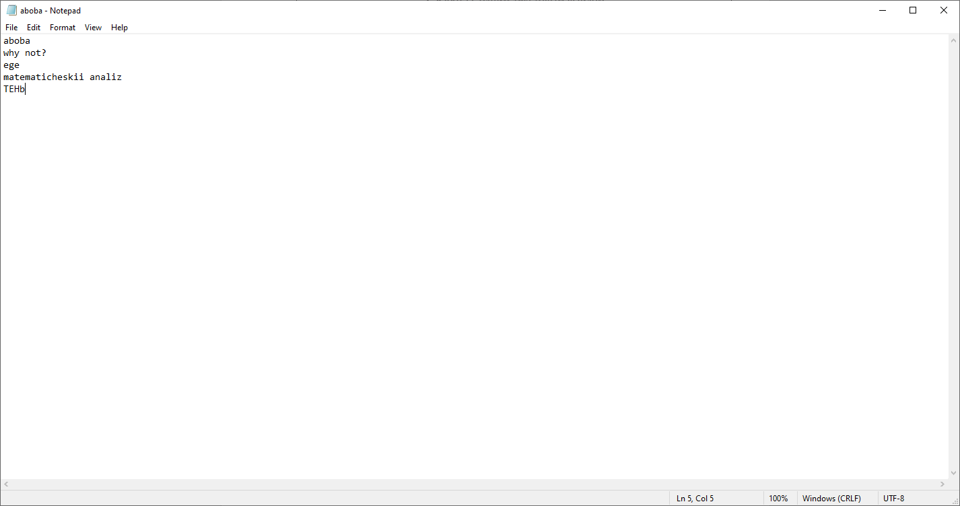

**Таблица значений**

|  |  |
| --- | --- |
| **Input** | **Output** |
|  | **ege 2 3** |

**9-II-15**

|  |
| --- |
|  |
|  |
| #include <iostream>  #include <algorithm>  #include "fstream"  #include <string>  using namespace std;  int main() {  ifstream in("input.txt");  ofstream out("output.txt");  string s, s1;  int x, x1;  while (in.peek() != EOF) {  in >> s;  in >> s1;  x = stoi(s);  x1 = stoi(s1);  out << min(x, x1) << endl;  }  } |

**Ввод**

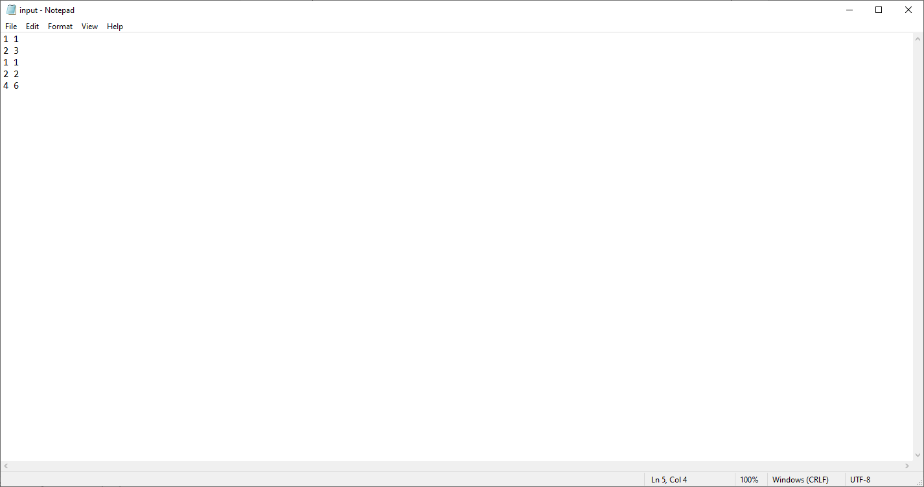

**Вывод**

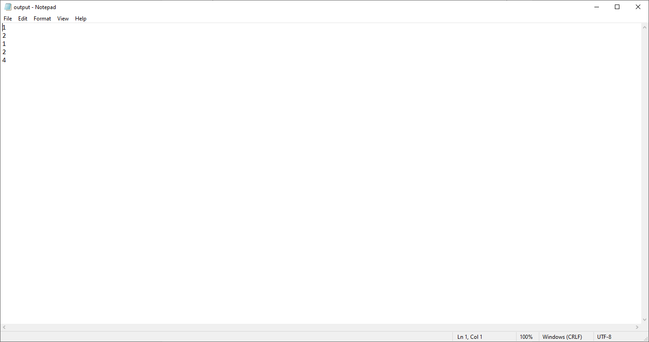

**10-I-1**

|  |
| --- |
|  |
|  |
| #include <iostream>  #include <cmath>  #include <string>  using namespace std;  struct point  {  double x, y, z;  point(double a, double b, double c);  double get\_rast();  void show\_coords();  };  point::point(double a, double b, double c){  x = a;  y = b;  z = c;  }  double point :: get\_rast(){  return sqrt(x\*x + y\*y + z\*z);  }  void point :: show\_coords(){  cout << x << " " << y << " " << z << endl;  }  int main(){  setlocale(LC\_ALL, "Russian");  int n;  double x, y, z;  string xs, ys, zs;  point \*points[100];  cout << "Введите количество точек\n";  cin >> n;  cout << "Вводите координаты каждой точки через пробел\n";  for (int i = 0; i < n; i++){  getline(cin, xs, ' ');  getline(cin, ys, ' ');  getline(cin, zs);  x = stod(xs);  y = stod(ys);  z = stod(zs);  points[i] = new point(x, y, z);  }  auto min\_point = points[0];  double min\_r = points[0]->get\_rast();  for (int i = 0; i < n; i++){  for (int j = 0; j < n; j++){  if (i != j){  if (points[i]->get\_rast() < min\_r){  min\_r = points[i]->get\_rast();  min\_point = points[i];  }  }  }  }  cout << "Найдена ближайшая к началу координат точка, вот ее координаты:\n";  cout << "x y z\n";  min\_point -> show\_coords();  } |

**Таблица значений**

|  |  |
| --- | --- |
| **Input** | **Output** |
| **3**  **1 1 0**  **2 5 0**  **10 12 0** | **x y z**  **1 1 0** |

**10-II-14**

|  |
| --- |
|  |
|  |
| #include <iostream>  #include "fstream"  #include <string>  using namespace std;  //члены данные  //члены функции  //название игрушки  //стоимость  //цензор  //уменьшить на x% стоимость  ifstream in ("input1.txt");  ofstream out ("output1.txt");  struct toy{  string name;  int x, cenz;  double cost;  toy(string name, double cost, int cenz);  void degrade\_cost(int x);  void out\_data();  };  toy::toy(string name1, double cost1, int cenz1){  name = name1;  cost = cost1;  cenz = cenz1;  }  void toy::degrade\_cost(int x){  cost = ((100 - x)/100.)\*cost;  }  void toy::out\_data(){  out << name << " " << cost << " " << cenz << endl;  }  int main(){  string title;  getline(in, title);  out << title << endl;  string name, cenz1, cost1;  double cost;  int cenz;  int x = 10;  while (in.peek() != EOF){  getline(in, name, ' ');  getline(in, cost1, ' ');  getline(in, cenz1);  cost = stod(cost1);  cenz = stoi(cenz1);  toy \*t = new toy(name, cost, cenz);  t->degrade\_cost(x); // инфляция, хаха  t->out\_data();  }  } |

Ввод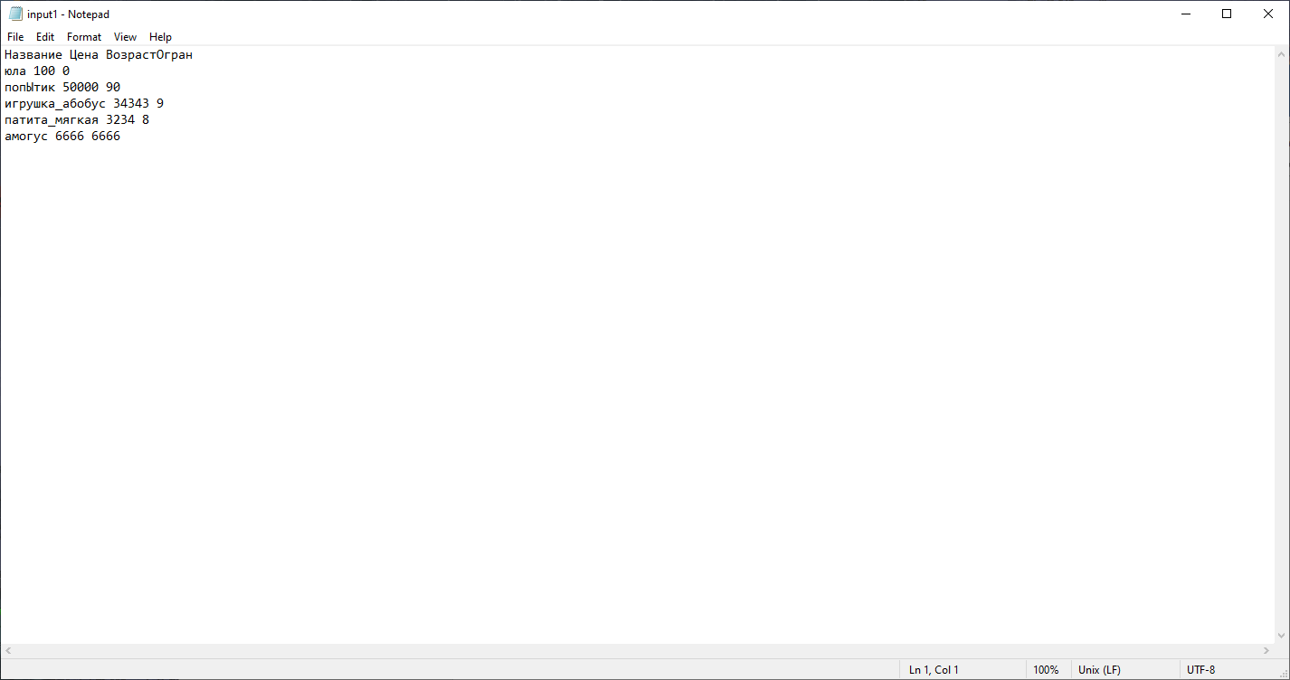

**Вывод**

**